**Objective Questions:**

1. What is the total number of attributes in the customer table?

**Ans:** In the Customer Table, The Total Attributes are **3 Attributes**.

They are:

* CustomerId
* Age
* Gender

1. How will you get the “Customer’s” ages in the “Order” tables according to customer IDs?

**Ans:** Using Data Modeling, making relationship between the 2 tables by using primary and foreign key. Or

**By using formula: CustomerAge =**

**LOOKUPVALUE(Customers[CustomerAge],Customers[CustomerID],Orders[CustomerID])**

1. In analysing the dataset with Power BI, ensure data cleaning to address inconsistencies and missing values before further analysis?

**Ans:**

* **Data Transformation**: I started by loading the dataset into Power Query Editor, which provided a robust environment for transforming and cleaning the data.
* **Removing Empty Rows**: I ensured that all columns in the dataset were free of empty rows. Empty rows can lead to inaccuracies in analysis, so I removed them to maintain data integrity.
* **Correcting Data Types**: The dataset included "Order Date" and "Delivery Date" columns, which were not initially in the correct format. I changed these columns to the "Date" data type to enable accurate date-based analysis, such as calculating delivery times or filtering by order dates.
* **Handling Missing Values in the "Reason" Column**: The "Reason" column, which indicated the reason for product returns, had some empty rows. I replaced empty rows related to returned products with "Unknown reason" and for delivered products, I filled the empty rows with "Not Applicable." This ensured the data was complete and logically consistent.
* **Eliminating Unnecessary Columns**: In addition to cleaning up empty rows and correcting data types, I also identified and removed unnecessary columns that were not relevant to the analysis.

1. How can we calculate the total revenue generated by all the sales?

**Ans:** By new column, firstly **Sales = Orders[Unit Price]*Orders[Order Quantity],**

Then, By taking new measure, **Total revenue = sum(Orders[Sales])**

**Total revenue = 105.94M**

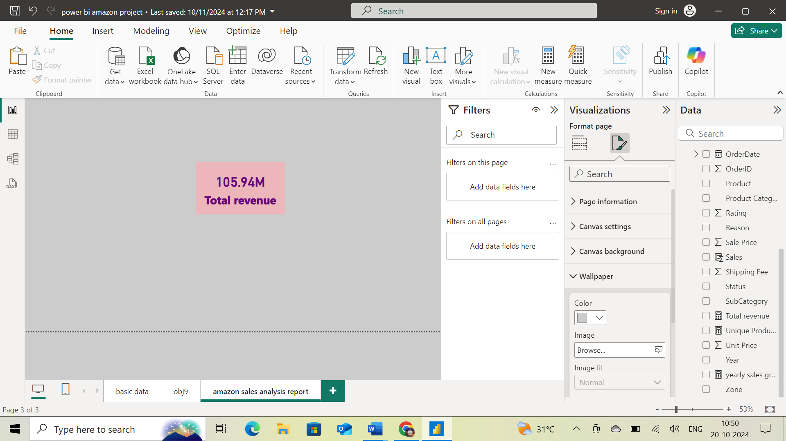

1. What is the total number of unique customers who made purchases each year? Is there any increase in the number over the years?

**Ans:**

Total unique customers **0.11M** who made purchases.

The approach is by creating a visual card and counting the Customer ID to get the values.

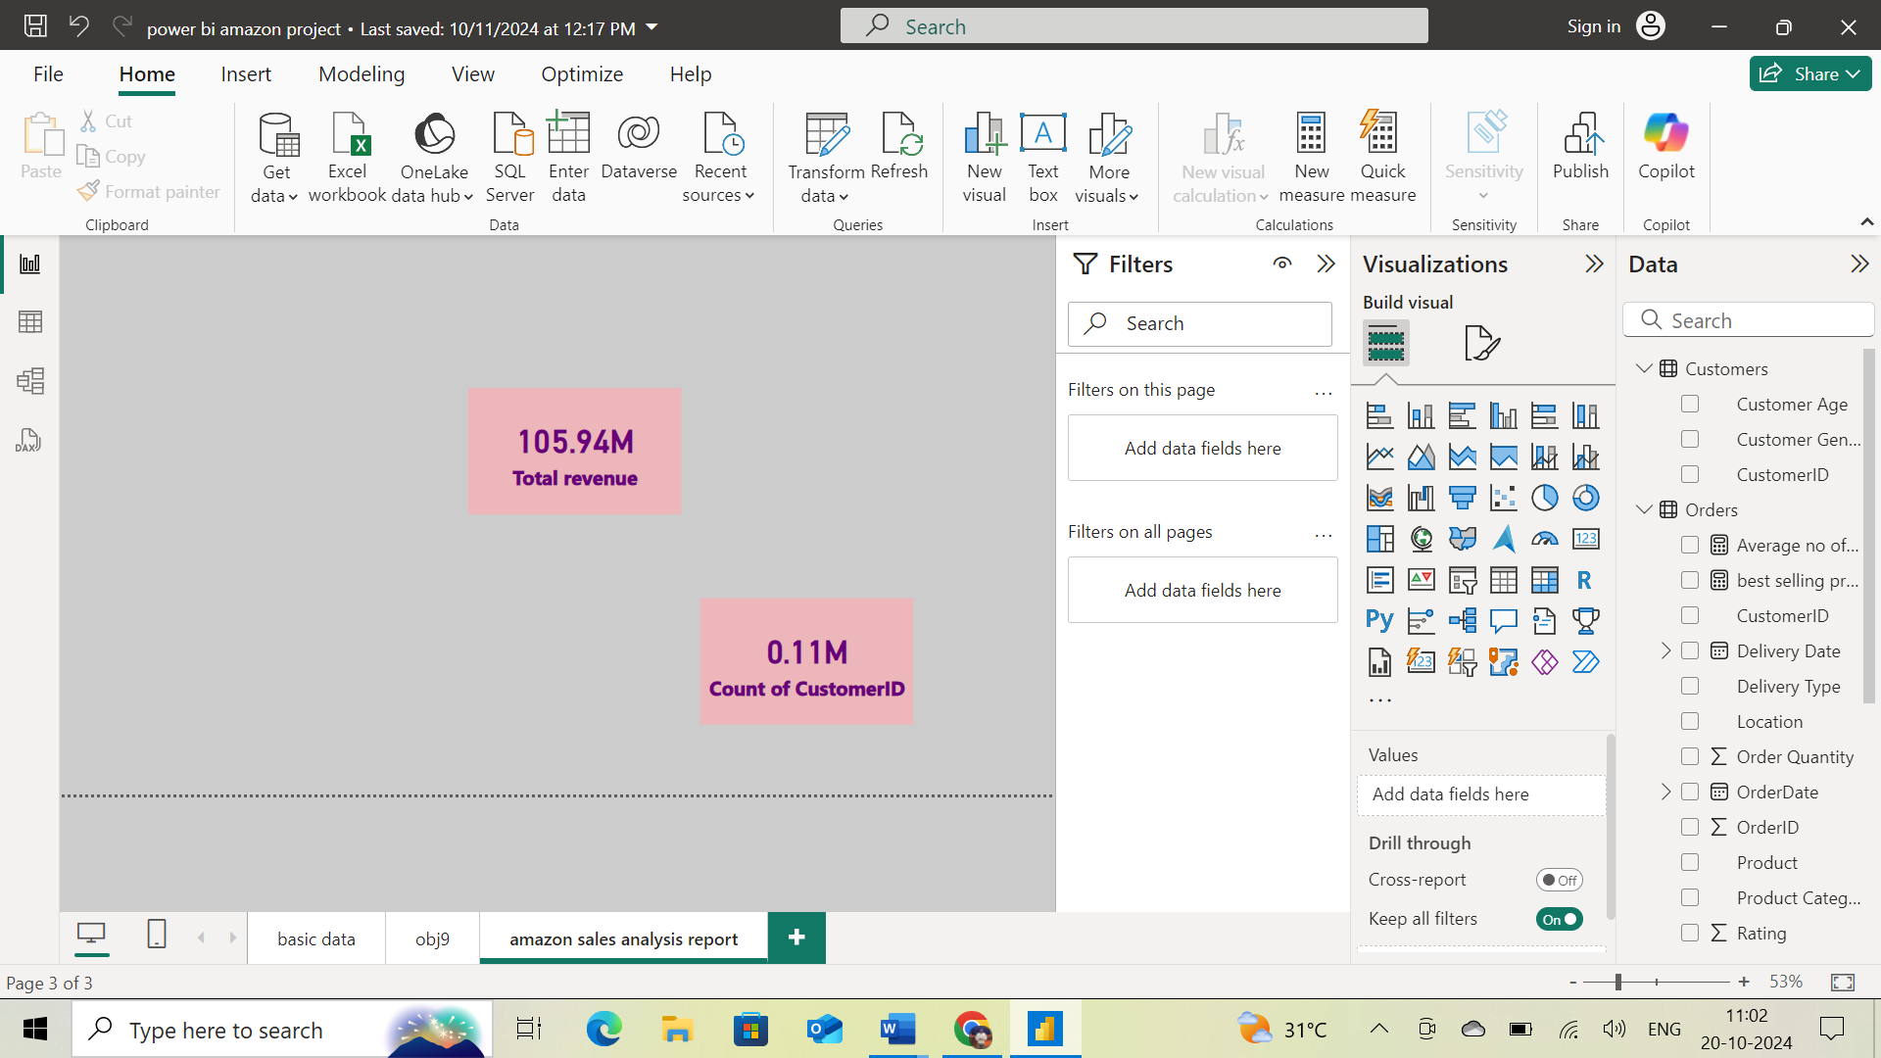

In the below stacked Bar chart, we can see how many customers made purchases each year. In x-axis Count of Customer ID and in y-axis Year. As we can see in the chart, there is an increase trend over the years.

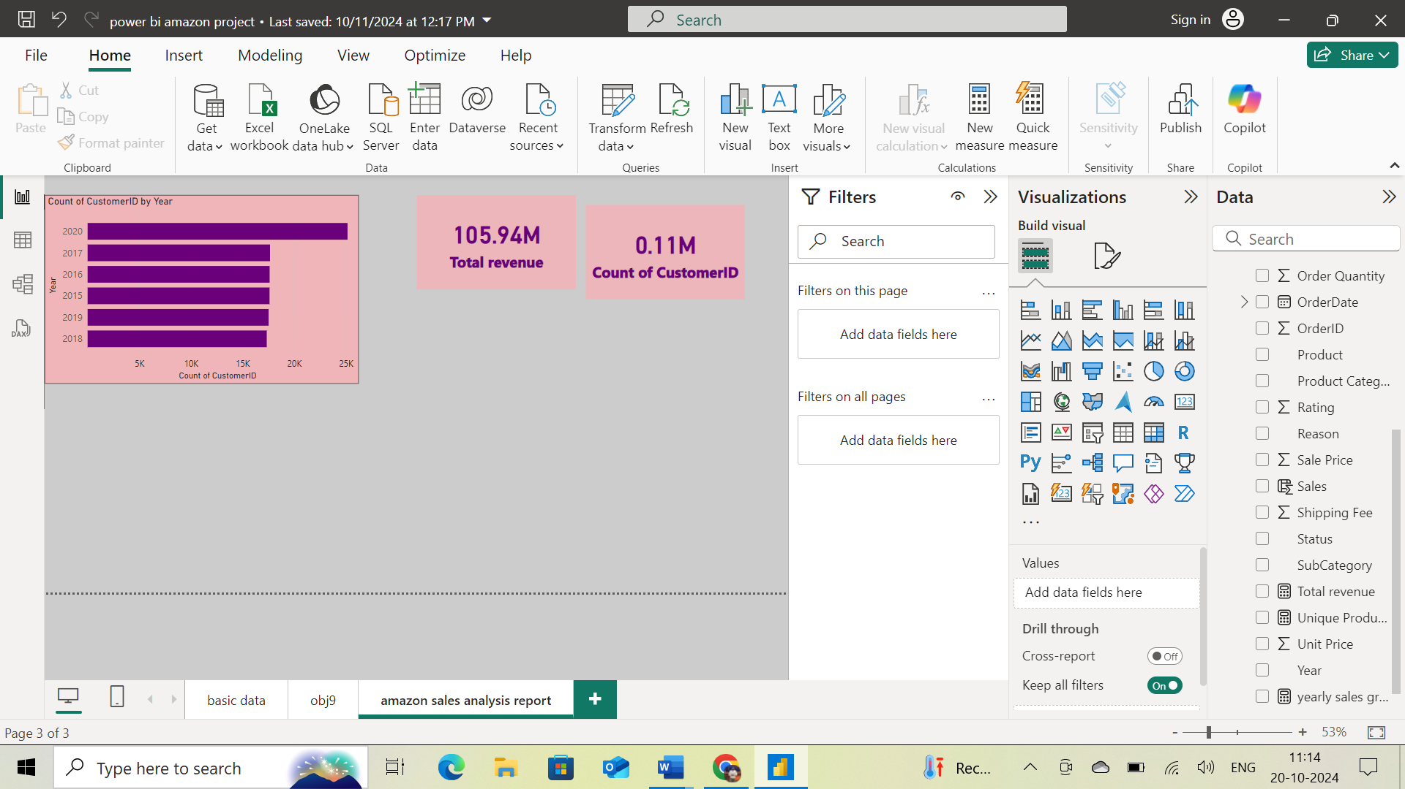

1. How can we determine the total number of unique products available in the company?

**Ans:**

By using **unique products = DISTINCTCOUNT(Orders[Product])**

**unique products = 45**

To show this value, I used card visual and by the Count of product column in the field we can determine the total number of unique products.

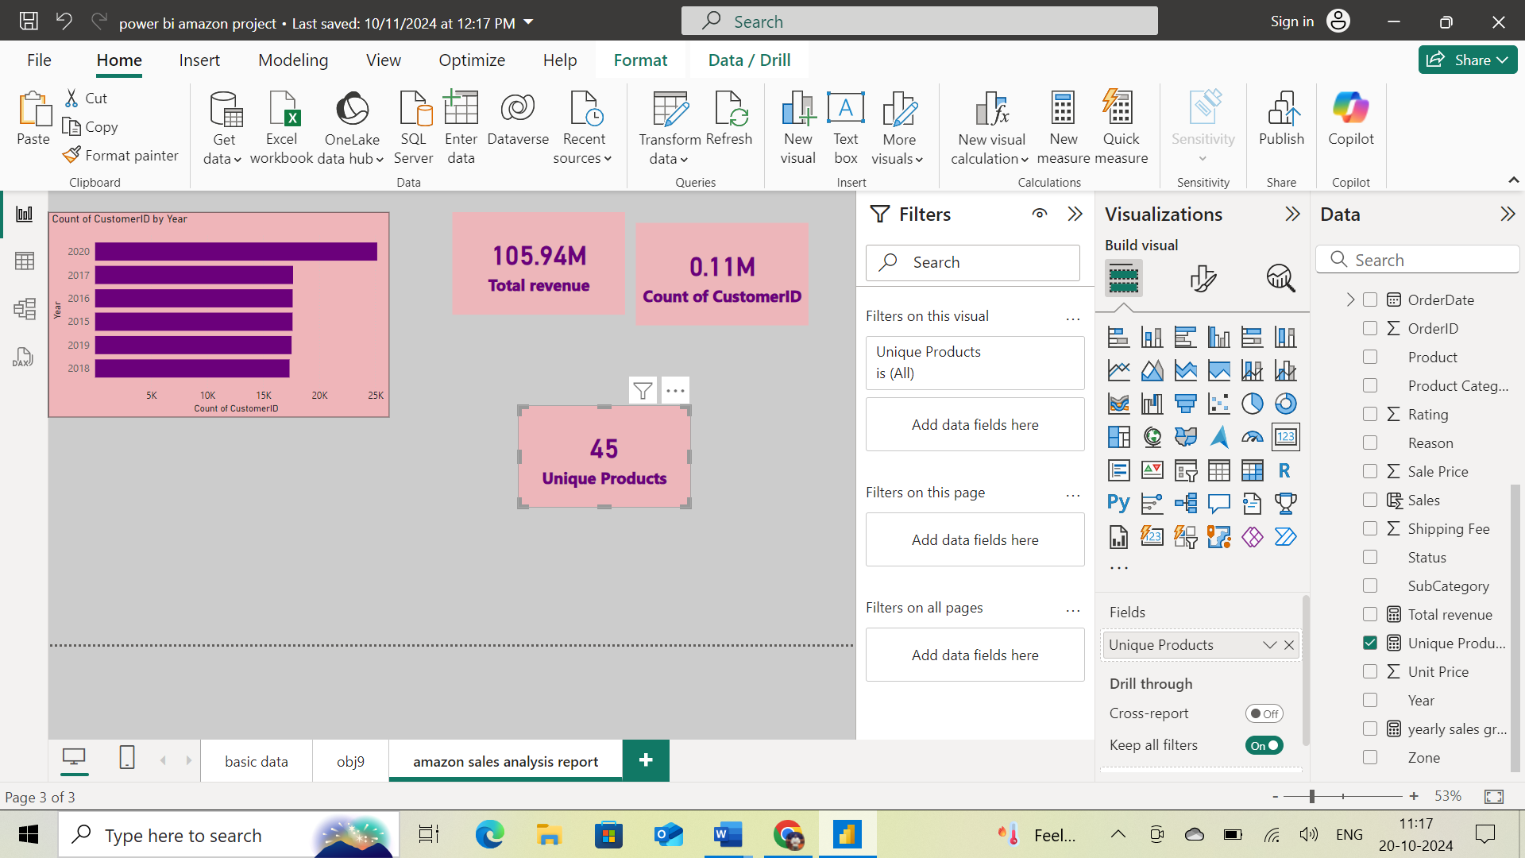

1. What is the average number of days it takes for products to be delivered, get the metric for only the delivered orders?

**Ans:** by using DAX

Average no of days between orders = **CALCULATE(AVERAGEX(Orders,Orders[Delivery Date]-Orders[OrderDate]),Orders[Status]="Delivered")**

**Average no of days between orders = 9.41**

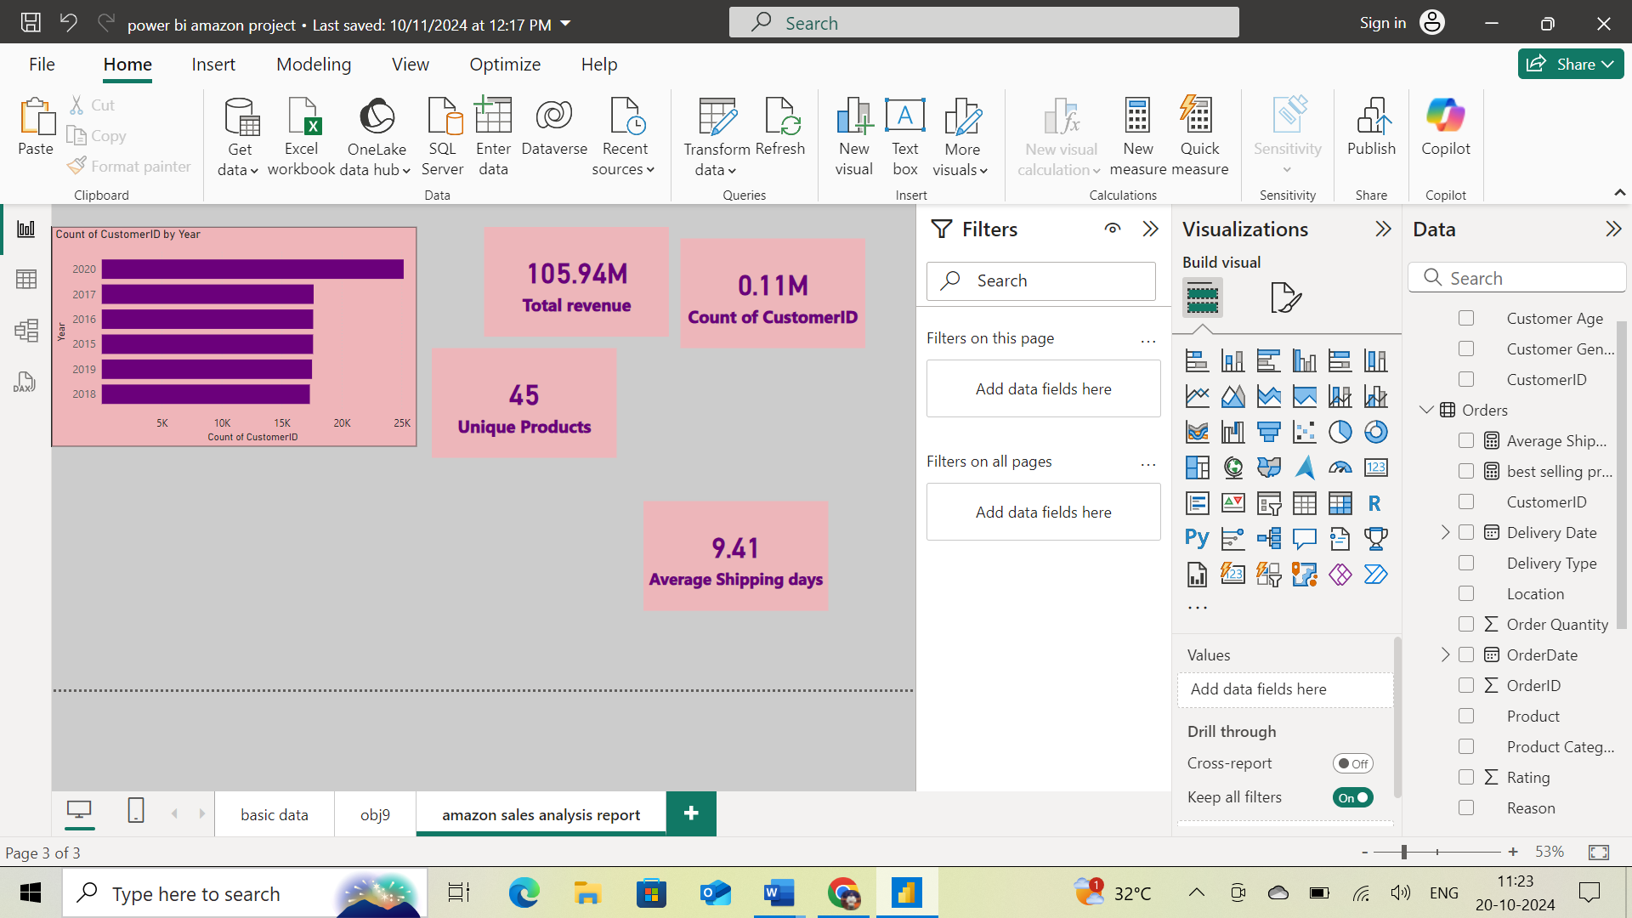

1. Which products, categories, and subcategories are the most popular?

**Ans:** To find popular product, categories, and subcategories by highest sales,**using TOPN function.**By using the Table chart and Filter Pane obtained the results. In the Filter pane, I filtered the product with Top 3 in Sum of Order Quantity.

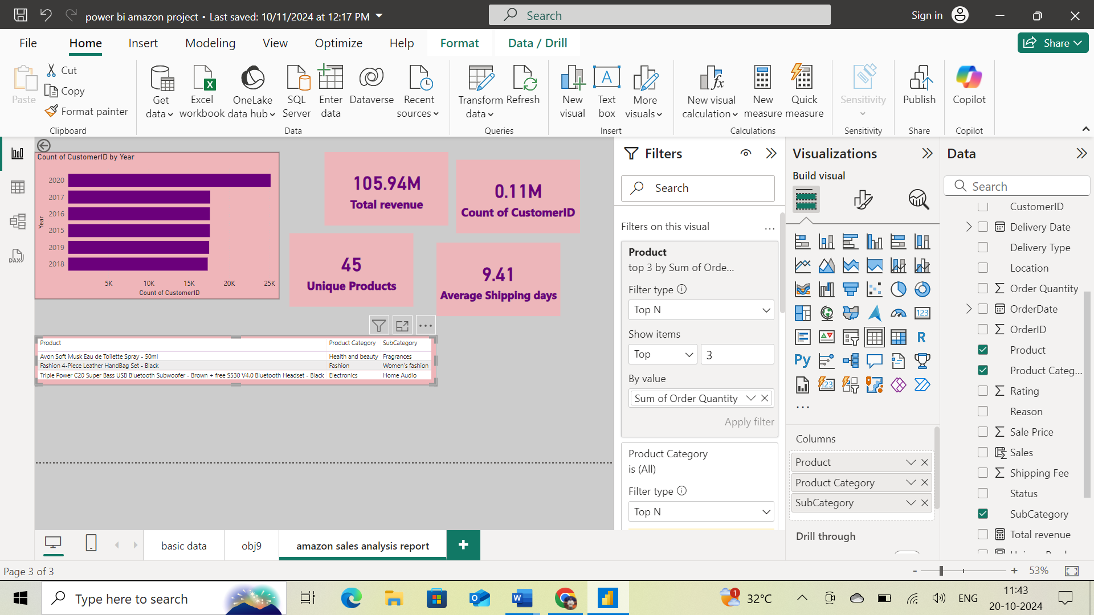

1. Which products have seen an increase or decrease in sales over the year?

**Ans:** I have used Stacked Area chart to show Sales Increase/Decrease for each product over the period of last 6 years.

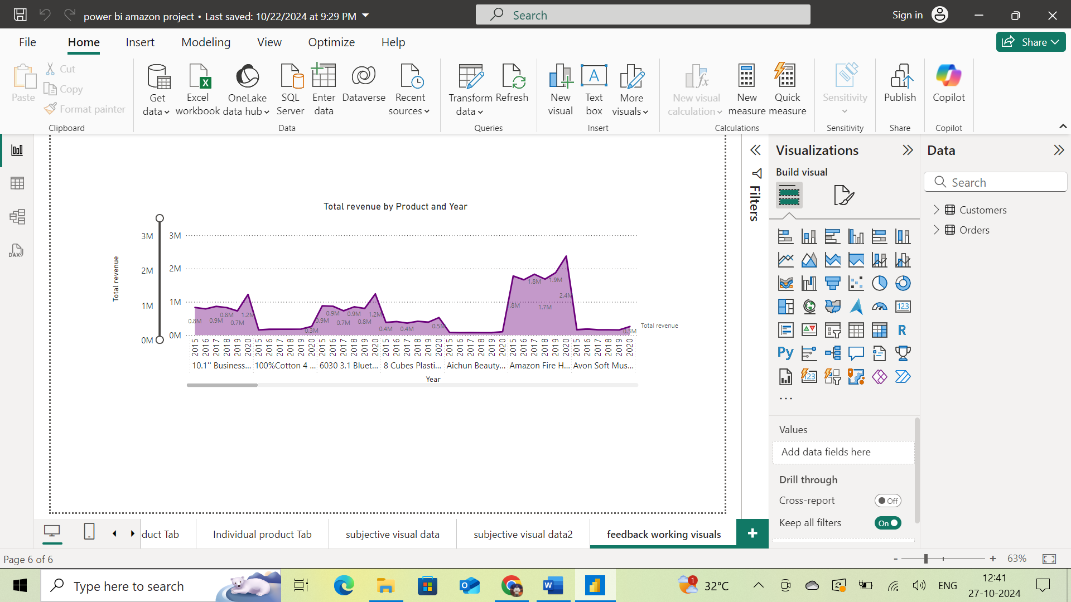

1. While modeling the data relationships, what will be the type of relationship between the customer ID of Orders and customer tables?

**Ans:** modeling the data relationship. type of relationship is : **Many to one relationship**

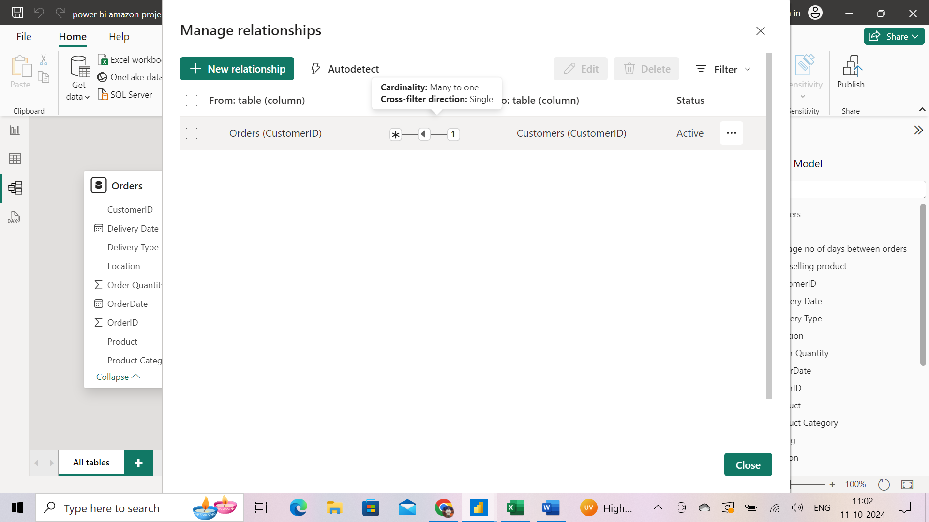

**From model view:**

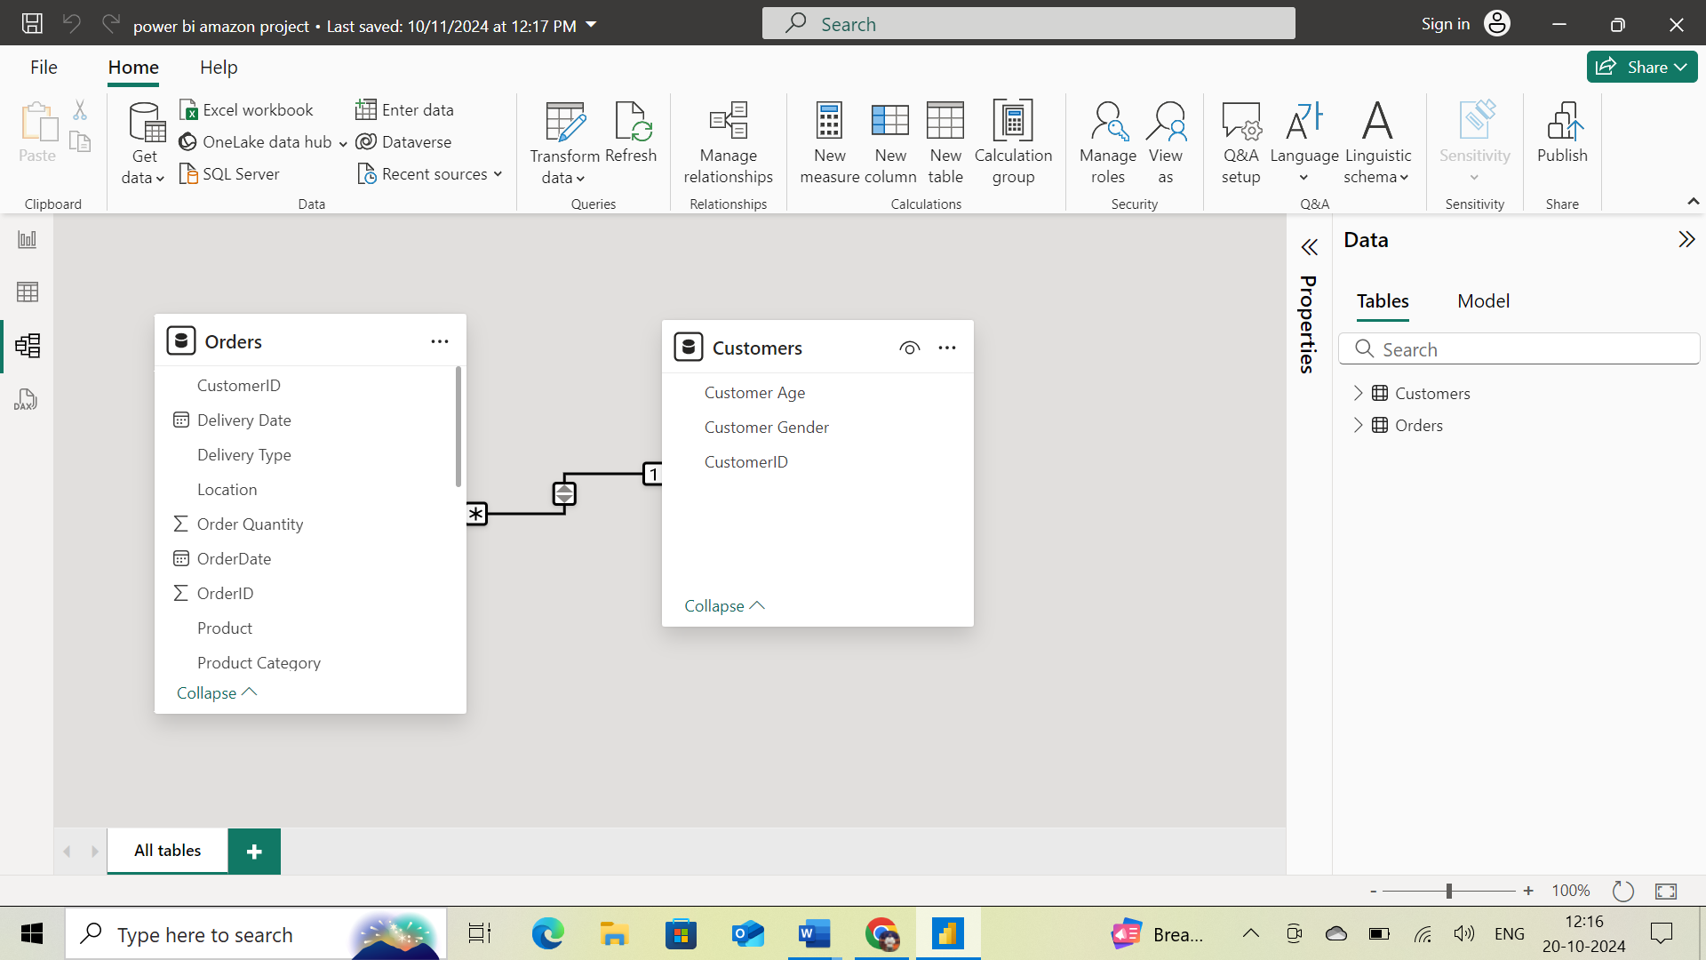

1. How have you handled the null values in the data?

**Ans:** To handle null values depends on the type of missing values , imputation methods such as mean, median, replace with random values ,can be used to fill in the missing values, if the data with complete rows and columns with null values, we can apply filter for them.

**In the reason column**, for empty rows which have returned products and “Not Applicable” reason for empty rows , but whose products were delivered remains same reason.

1. Were there any data format issues in the data, and if there were/are how you would handle them?

**Ans:** During the Amazon e-commerce sales analysis report. I encountered several data format issues that required cleaning for accurate analysis. To address these issues, I utilized the Power Query Editor in Power BI. The steps involved were as follows:

1. **Loading Data into Power Query Editor**: I imported the dataset into the Power Query Editor to begin the data transformation and cleaning process.
2. **Handling Empty Rows**: One of the initial tasks was to ensure data integrity by removing any empty rows from the dataset. Empty rows can lead to inaccurate results in the analysis, so it was essential to eliminate them to maintain data consistency.
3. **Correcting Data Types**: The dataset included columns such as "Order Date" and "Delivery Date," which were initially in an incorrect format (e.g., text or general type). I changed these columns to the "Date" data type to enable proper date-based analysis, such as calculating the delivery time or filtering orders by date.
4. **Removing Duplicates**: To ensure there were no duplicate records that could skew the analysis, I checked for and removed any duplicate entries within the dataset.
5. **Data Type Consistency**: Beyond dates, I ensured that all columns had consistent and appropriate data types, such as changing numerical values stored as text into proper number formats, which is crucial for performing calculations and aggregations
6. When we add a column in Power Query what’s the code that comes in M language in the formula bar? What do you know about M-query?

**Ans:** added a column in power query editor, the **m-code in formula bar is**

= Table.AddColumn(#"Removed Columns", "Year", each Date.ToText([OrderDate],"yyyy"))

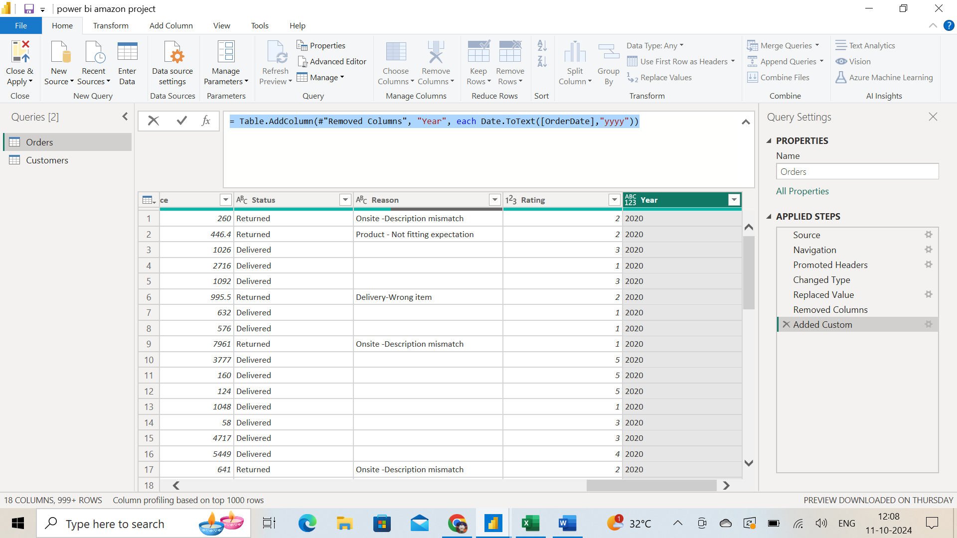

**M-Query:** a functional programming language used in Power BI to transform and prepare data, M Query allows users to clean, reshape, and combine data from multiple sources. It's used to create data mashups by filtering and combining data from various sources

**Subjective Question:**

1. Explain the revenue breakdown by year and by-product. Evaluate how different products contribute to annual revenue and come up with suggestions to increase the sales of the low-selling items.

**Ans:**

**Insights:**

* Here, the above task asking to find revenue breakdown by year and revenue breakdown by product.
* Asking to give suggestions to increase the sales for low-selling items.

**Approach:**

* To solve this, I used stacked column charts for total revenue by year and total revenue by product.
* In the first stacked column chart, we can see how revenue break down by each year. By x-axis is year and y-axis is total revenue.
* In the second stacked column chart, it is noticeable how different products contribute to annual revenue. By x-axis is product and y-axis is total revenue.

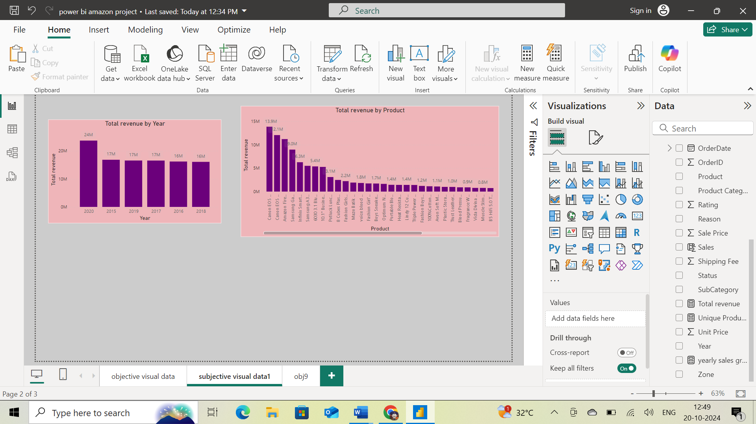

**Recommendation:**

* To increase the sales of low-selling items

1. We can use some strategies like Selling in a bundle of low-priced items to increase their revenue.
2. marketing promotions for low selling items.
3. Giving more points on the purchase of that product etc.
4. Give a different payment options to customers.
5. Offer discounts.
6. How many products were returned? Use a DAX function to get this metric. Examine the possible reasons for returns and consider how this metric could indicate improvements in product descriptions or quality control.

**Ans:**The total number of returns is 31k with 44 unique products.

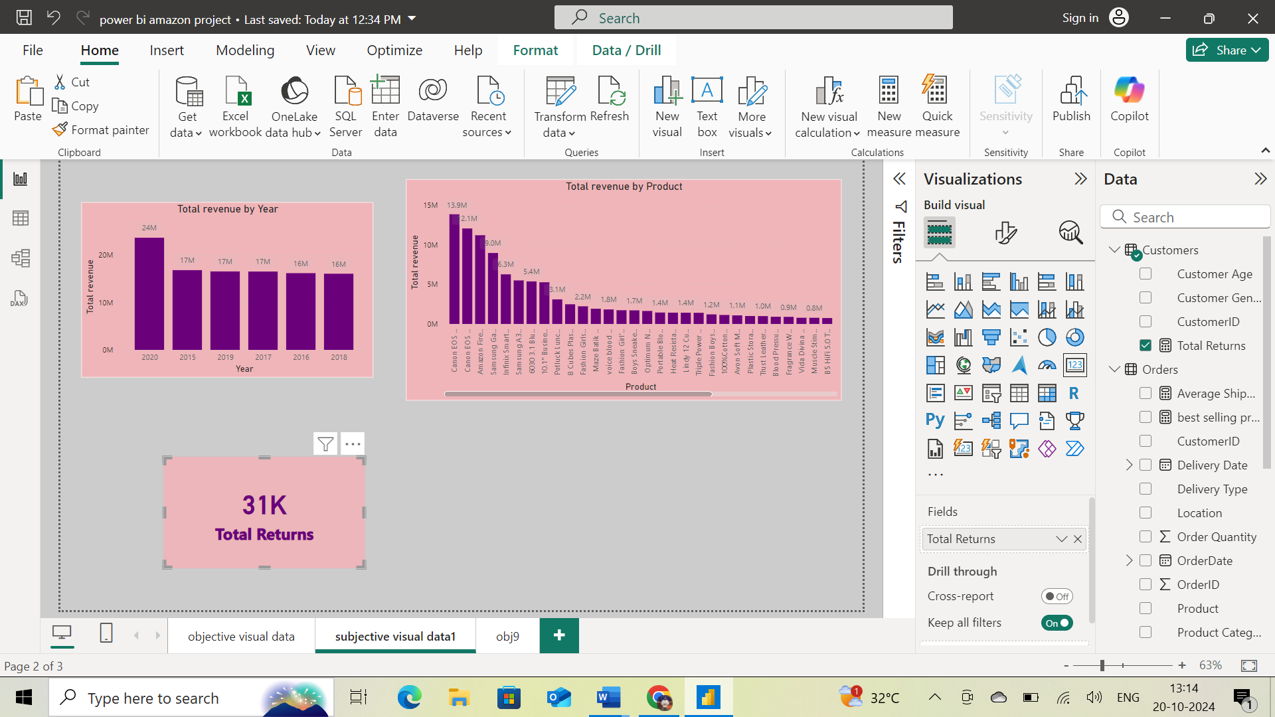

The possible reasons for the returns are:

* **Defective items** - Delivering the defective items makes customers lose interest in the quality of the brand. So, make sure before going for a package the quality of the product needs to be checked.
* **Delivery Missing item/part** - Product description should mention clearly all the components and should provide a checklist of what's included.
* **Onsite Description Mismatch** - Product description should match with the products that are going to deliver otherwise it leads to customer dissatisfaction. Make sure to regularly update the description in the online platform.
* **Product not fitting expectations** - Make sure the size chart provided in the product description shows multiple options for customers to choose perfect size.
* **Delivery wrong item** - Have multiple checkpoints to see if the right product is going for a package before delivering the product.
* **Unknown Reasons** - There are some unknown reasons for the product to be returned. Make sure while collecting the return packages take note of the reasons for return for better understanding.

1. Whenever a customer goes to Amazon, they’ll filter the most rated products to buy the better category. Can you verify this using any visualization or table that the ratings of products impact their sales value?

**Ans:**

**Insights:**

* The above task asking to get, a visualization or table, based on average sale price in products with their ratings.

**Approach:**

* To solve this, I used area chart, with column names rating on x-axis and average of sale price on y-axis. used some format visual tool options to build the below chart style.

**Recommendation:**

* From the given data, it is evident that products with lower ratings have higher sales. This could be for several reasons like immediate need of the product, low price of the product, availability of the specific product in the platform, specific brand etc.

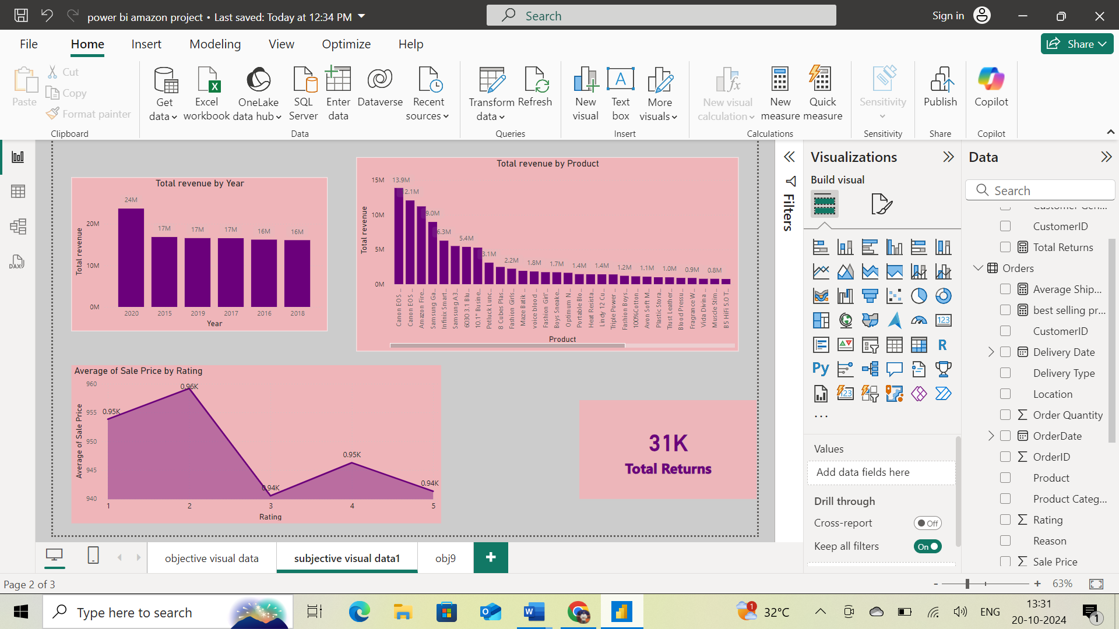

1. Investigate how revenue distribution varies across different locations. Explore which geographical areas contribute most to sales and consider the strategic implications for regional marketing and distribution efforts. How might location-based trends inform the company's market segmentation and resource allocation approach?

**Ans:**

**Insights:**

* The above task is asking to get, visualization across different locations with sales of product.
* Asking strategic implications for regional marketing and distribution efforts. geographical areas contribute most to sales
* informing market segmentation and resource allocation for company.

**Approach:**

* To solve this, I used map chart with columns location and average of sale price.
* Used format visual for showing areas with bubble and size of it.

**Recommendation:**

* From the below Map chart, we can see the revenue distribution across different locations. As we can see North America and African regions contribute most to sales. As for distribution, collaborate with regional delivery partners to accommodate smooth delivery. Regional marketing should involve the traditions of that particular region so that it affects the sentiment of the customers and it attracts more customers.

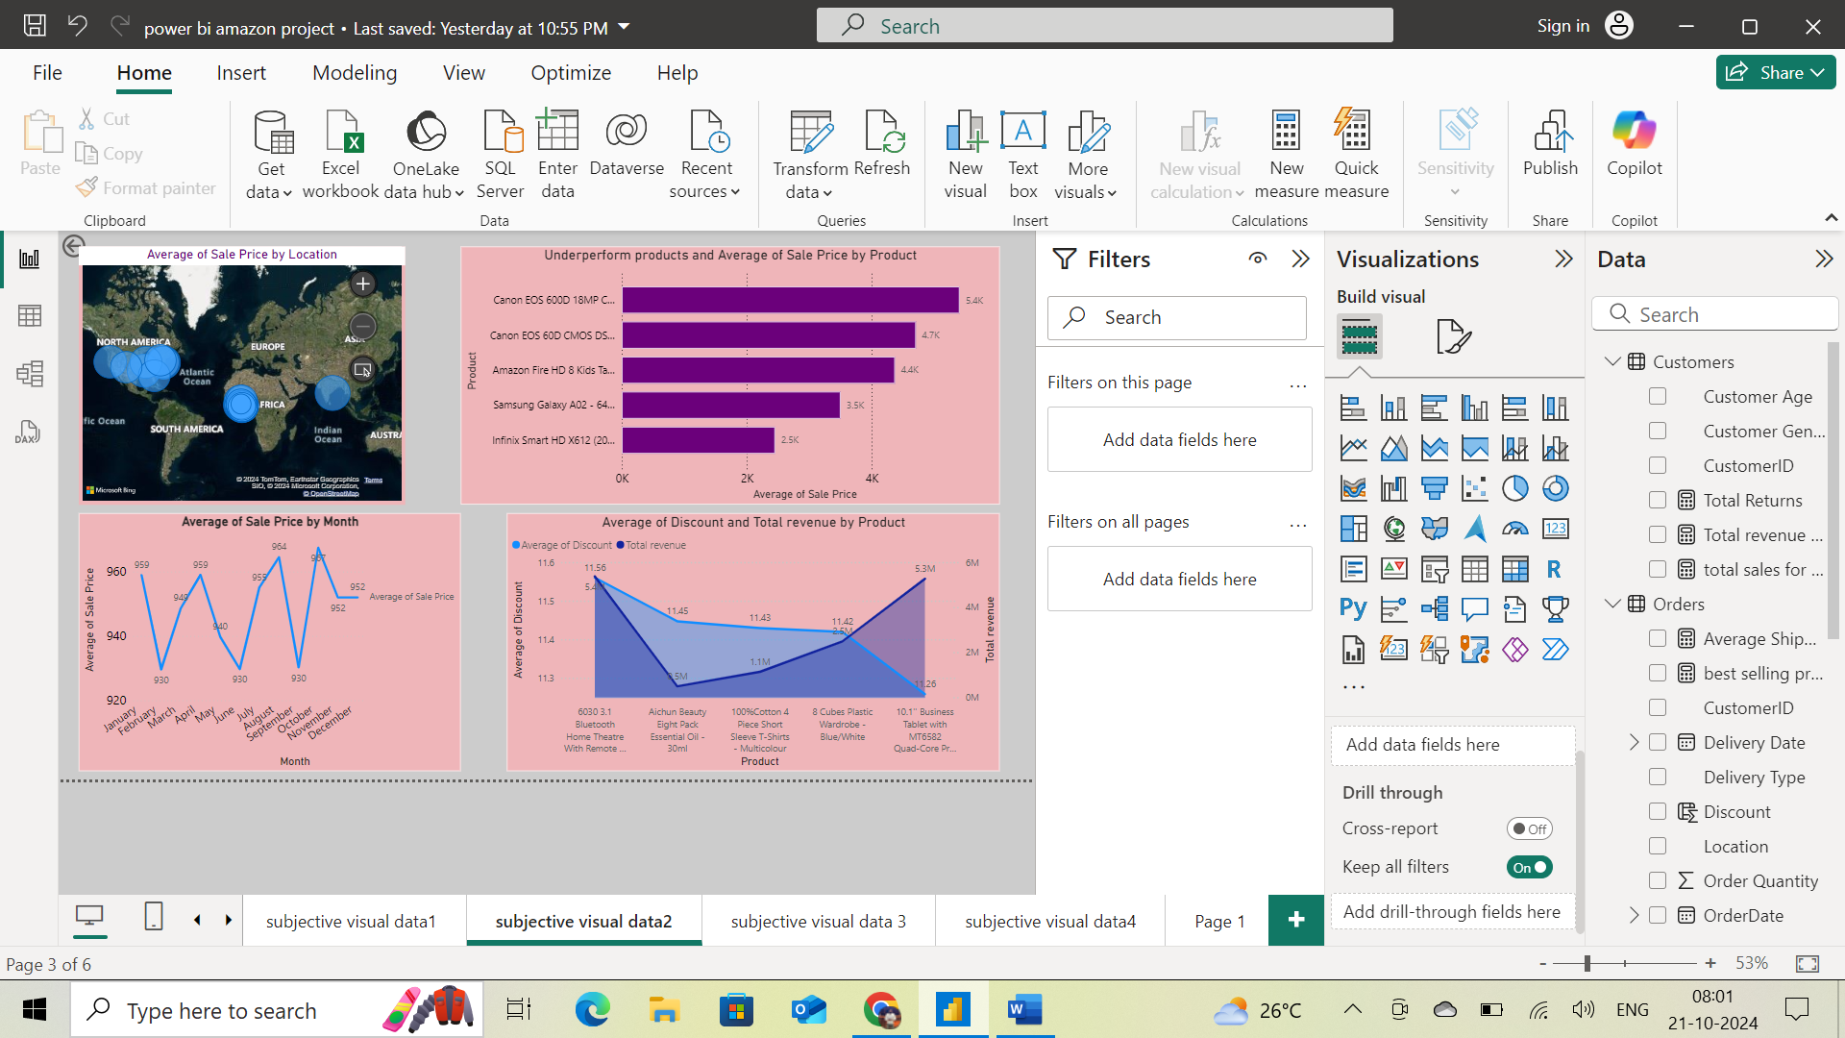

1. Determine which month could benefit from enhanced promotional offers to boost sales. Can you suggest some targeted marketing strategies here?

**Ans:**

**Insights:**

* The above task is asking to get, month wise sales in the company. To boost sales, by giving promotional offers.
* suggest some targeted marketing strategies

**Approach:**

* To solve this, I used line chart with columns order-date(month) and average of sale price to get average monthly sales.
* By using, format visuals for chart styles.

**Recommendation:**

* From the below Line chart, we can see the Month wise sales in the company. As we observe the chart February, June and September sales are slightly less compared to other months. From enhanced promotional offers these months could benefit to boost sales.
* **Targeted marketing strategies** like Time limited sales, special discounts and incentives on that particular month could increase the sales. Go for more advertising on that particular month with the special deals.

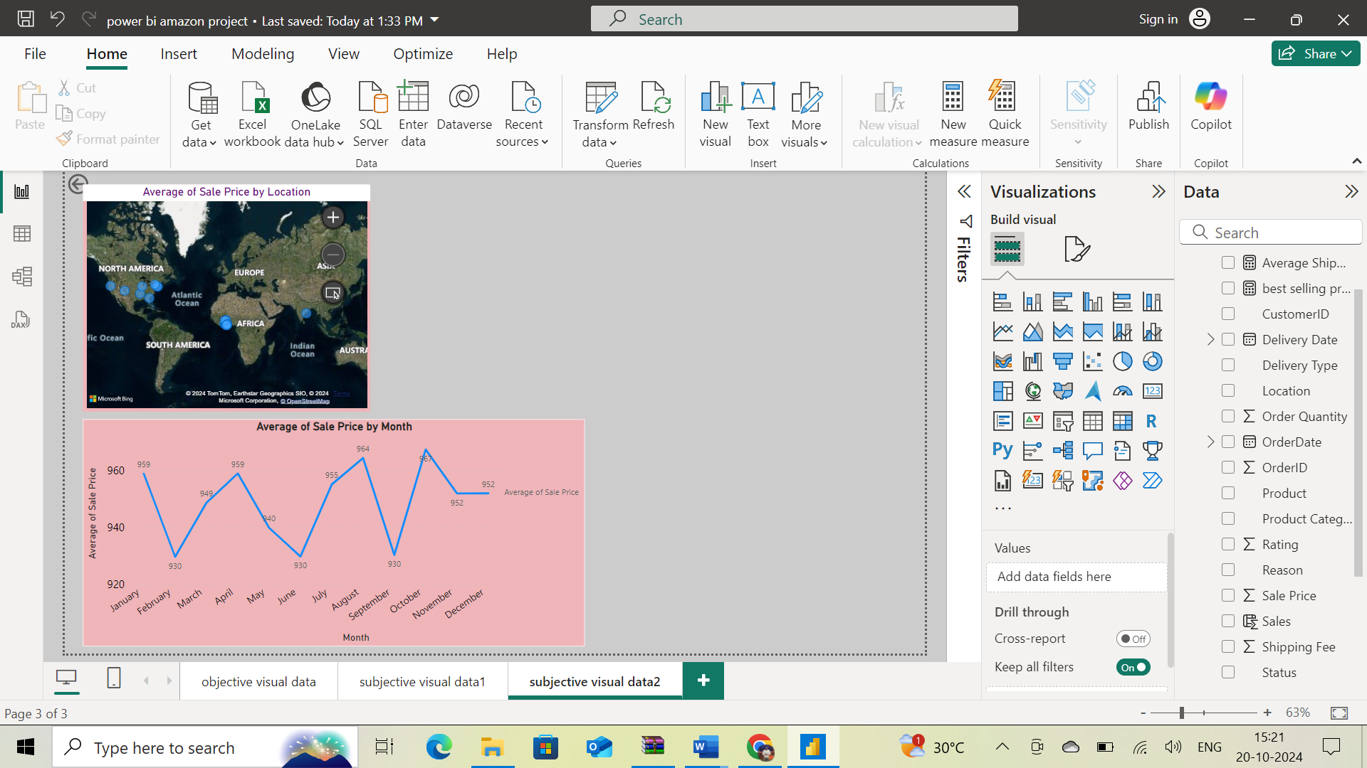

1. Identify which products may require increased marketing efforts. Which items have high prices yet underperform in sales?

**Ans:**

**Insights:**

* the above task is asking to get, to identify underperforming products with high prices by sales. To increase marketing efforts.

**Approach:**

* I used a stacked bar chart to solve this, by using columns like product on y-axis and average of sale price on x-axis
* Used format visual for chart style.
* Filtered lowest sales, Top 5 products by using filter visual plane.

**Recommendation:**

* From the below stacked Bar chart, these are the 5 underperformed products which may require increased marketing efforts.
* With the average of sales performance against products by using stacked Bar chart and using filter plane top 5 products, with lowest sales, I got the results.
* having high price, the average sales of these products are very low.

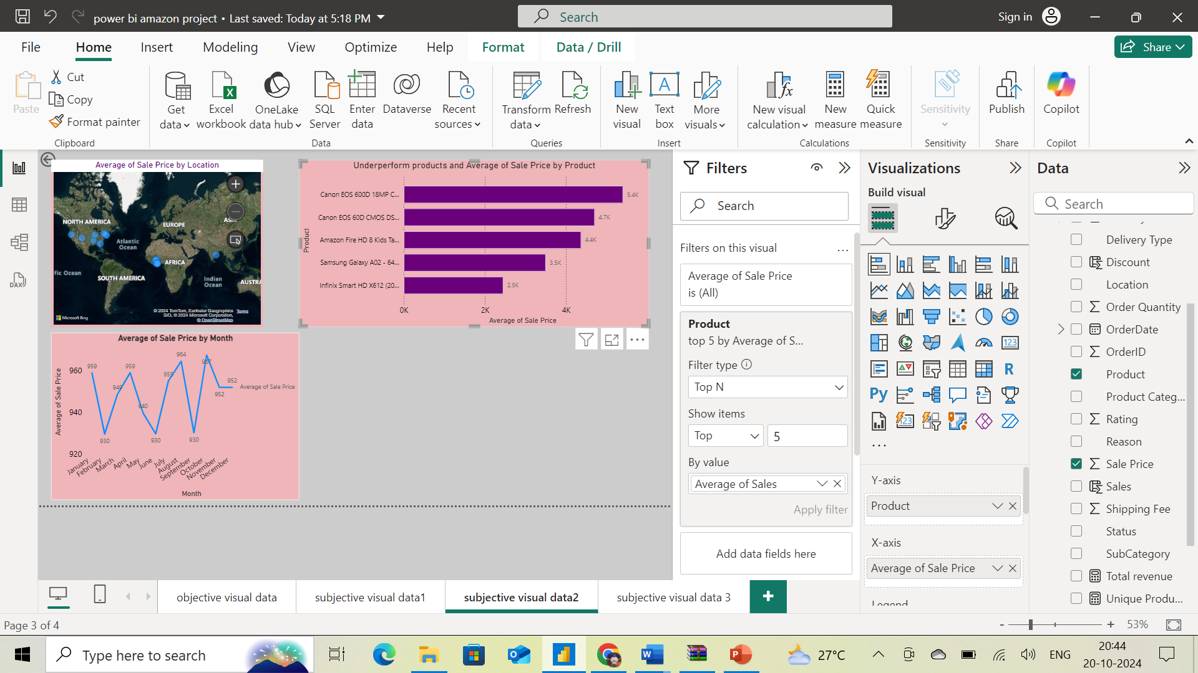

1. Assess which products should have discounts. How can targeted incentives drive sales and customer loyalty for specific products?

**Ans:**

**Insights:**

* The above task is to get, Asking for products by customers with specific discount.

**Approach:**

* To solve this, I used Area chart, with columns average of discount on y-axis and product on x-axis.
* Used format visual for chart style.
* Filtered lowest sales Top 5 products by using filter visual plane.

**Recommendation:**

* As we see in the below Area chart, these are the products with lowest discounts. If we have more discounts for these products, we can drive more sales which will result in more revenue.

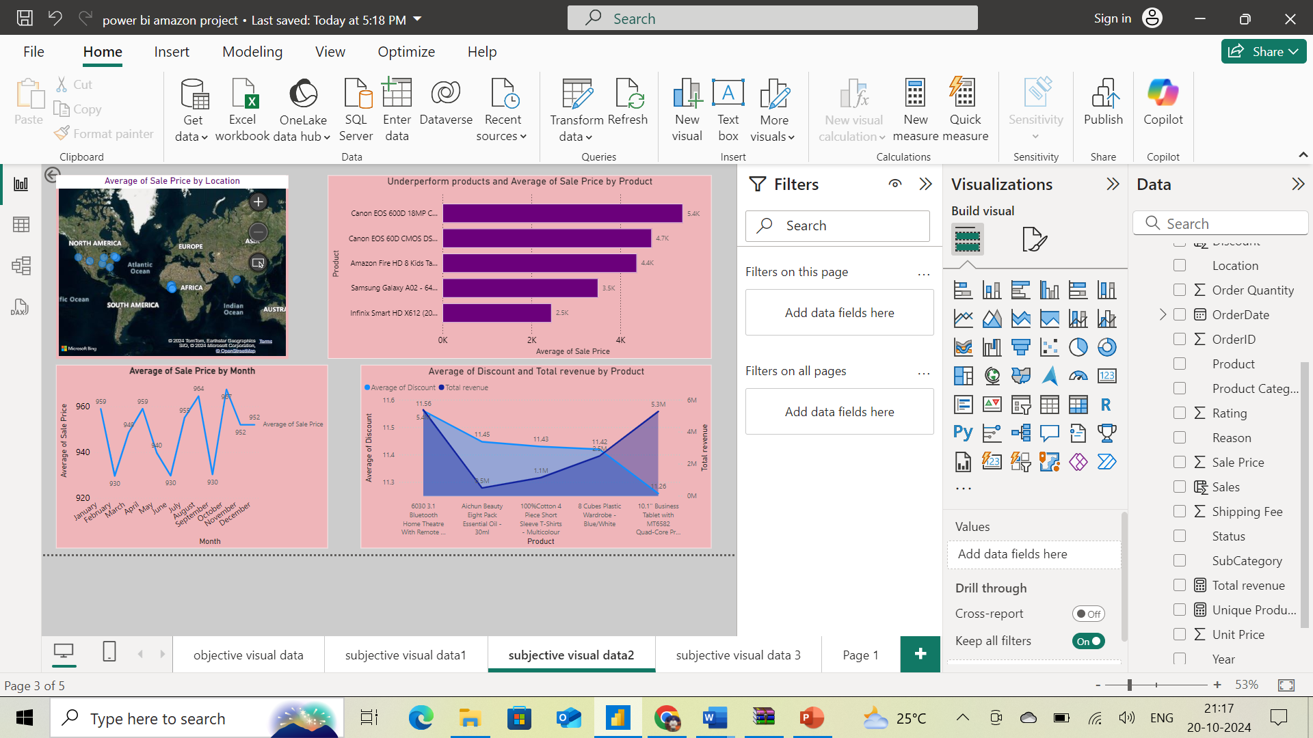

1. Come up with a loyalty program to benefit the company’s customers. From the available lot of customers come up with strategies to bucket them and provide benefits under different loyalty programs.

**Ans:**

**Insights:**

* The above task is to get, count of customers with sales of products**.**
* Asking to convert customers in groups.
* Asking marketing strategies

**Approach:**

* I used a pie chart to solve this, using columns sale price and customer-id
* Used format visual for chart style
* Grouping customers with sale price with below 5 categories

I have grouped the customers into 5 categories based on the spending capacity.

1. **VIP Program for High End Customers** - These customers are the highest spenders with minimum sale price of 5041-8180. We can provide premium services tor these customers like early access to big sales.
2. **Reward Points Premium Customers** - Premium customers minimum spending amount is 3501-5040. Giving points on every spend will be a reward for their loyalty.
3. **Special Discounts for Standard Customers** – Standard customers usual spend minimum of 1651 -3500. Giving rewards on special occasions like birthdays will make the customers happy.
4. **Card discounts for Economy Customers** – Customers with minimum spending amount of 151-1650.are the economy customers. We can provide Card discounts for them if they pay money through their debit or credit cards.
5. **Cashback and High Discounts for Budget Friendly Customers** – These customers mainly focus on their budget. If the sale price is between 4 -150.then only, they will purchase the products. So, giving cashback and high discounts will attract these customer

**Recommendation**:

* The below pie chart shows the bucket of customers. with a loyalty program to benefit the company’s customers.

**marketing strategies:**

* Personalized Marketing
* In-App or In-store Notifications
* Social Media and Content Engagement

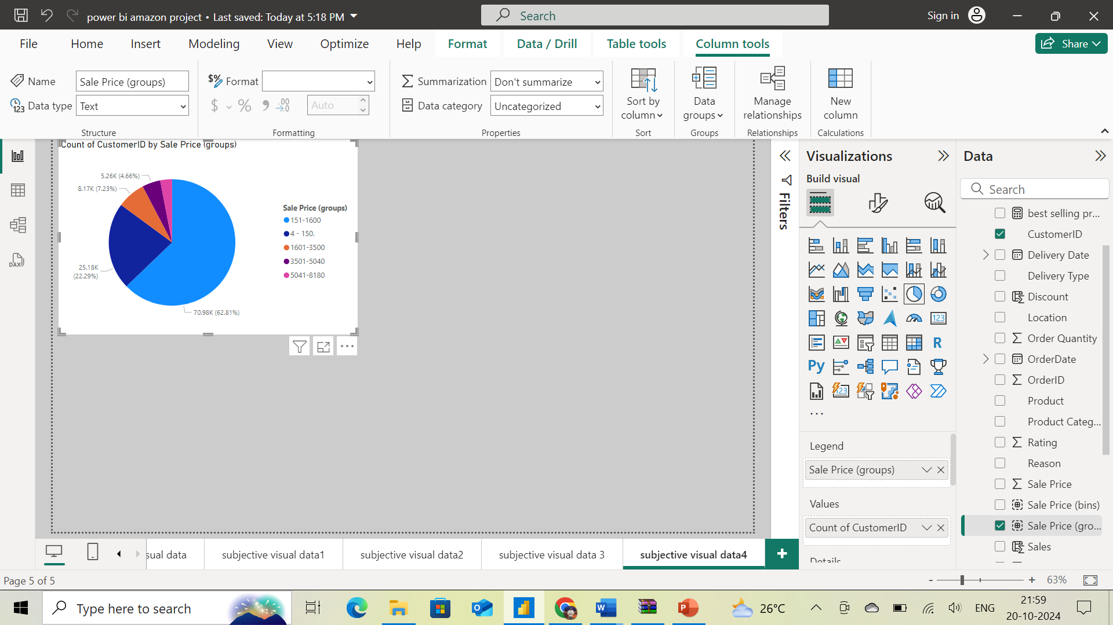

1. Using the DAX functions Calculate and a row iteration DAX function calculate the total sales for the Product Category “Fashion” and delivery type “Shipped from Abroad”. What are the other types of DAX functions you have used in the project?

**Ans:**

**Insights:**

* Asking to find DAX function.to find total sales for fashion with filter for shipped from Abroad
* Asking Other types DAX functons, we can use to solve this.

**Approach:**

* To solve this, used a new measure option in the table tools.in ribbion bar

The Dax formula for Calculating total Sales for Product Category **“Fashion”** and delivery type **“Shipped from Abroad”** is

**total sales for fashion = CALCULATE(sumx(Orders,Orders[Sale Price]),Orders[Product Category]="Fashion",Orders[Delivery Type]="Shipped from Abroad")**

* I dragged the column name **total sales for fashion** from data, used a number card in visual plane, to show the below visualization.

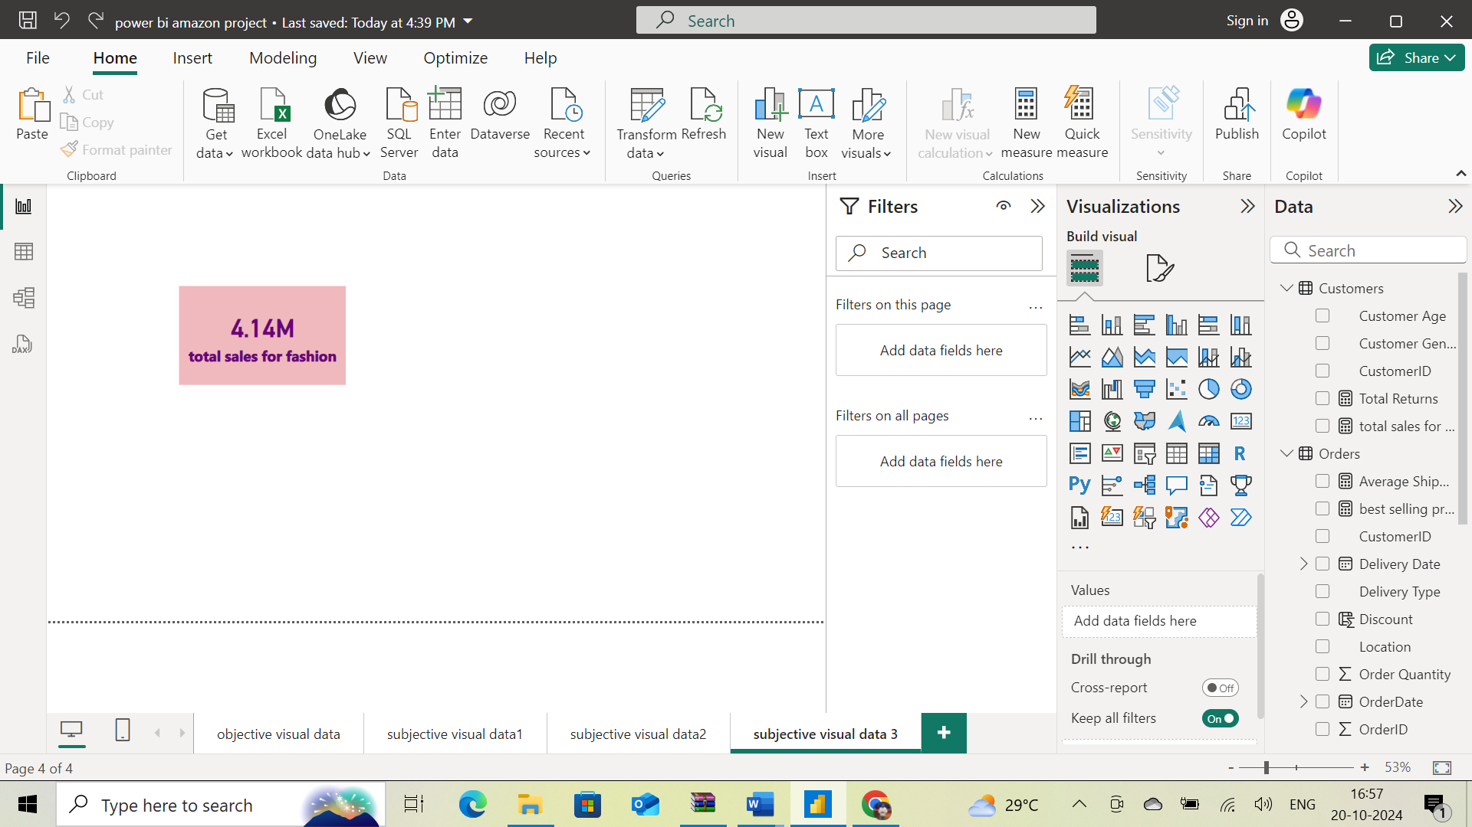

**Recommendation:** other DAX functions

* **SUMX**: Row-wise Aggregation with Conditions
* **ALL and REMOVEFILTERS**: Remove Filters if Needed

1. Wait Times Correlated with Demographics and Care: Explore how average wait times vary across different product categories to optimize scheduling and staffing.

**Ans:**

**Insights:**

* the above task is asking to find, average shipping day of product by customer age group
* and average shipping day by product category, asking for visualization

**Approach:**

* I used 2-line charts, with columns customer age on x-axis and shipping days.
* to this created a line chart, with columns product category on x-axis and shipping days on y-axis
* Used format visual for chart style

**Recommendations:**

* Here Wait Time means Delivery Time from my dataset**. In the first Line chart,** we can see how wait time correlate with demographic i.e. Customer age. In the graph, above 60 years age group the average delivery time varies from 8.34 days to 13.50 days. Below 60 years there is no much variation in the average delivery time.

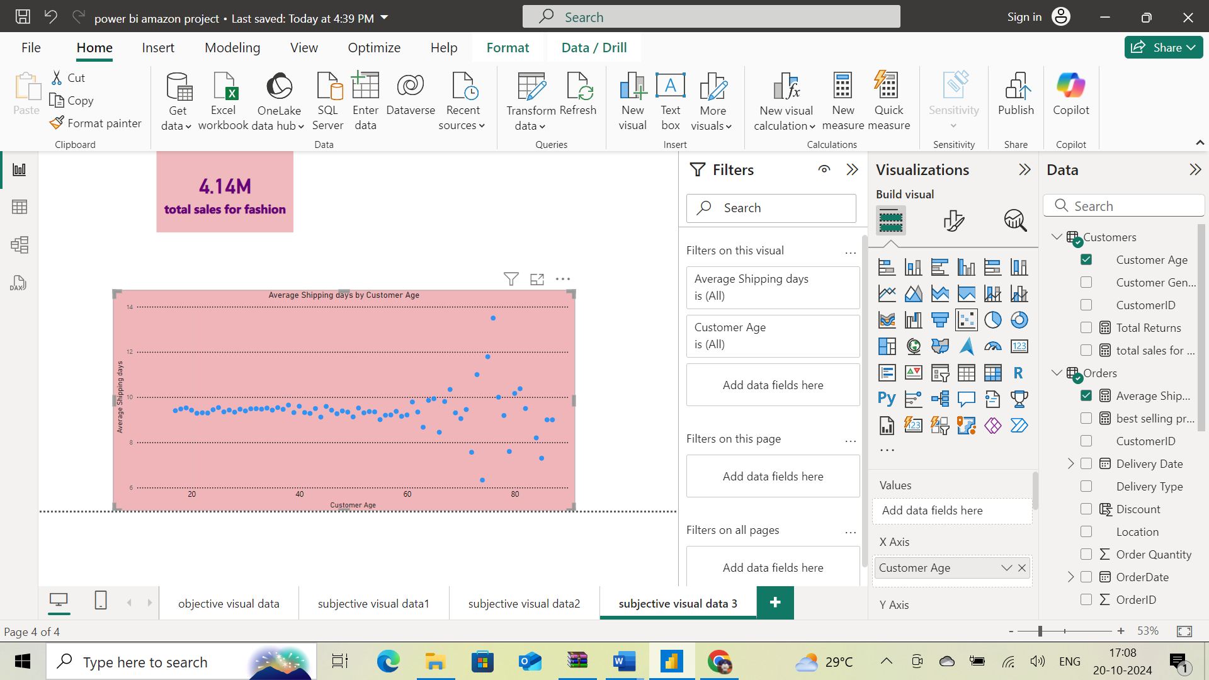

* **In the second Line chart**, we can see how average wait time vary across different product categories. For “Phones and Tablet” the average delivery time is 9.455 which is more compared to other product categories. We can do the scheduling and staffing accordingly.

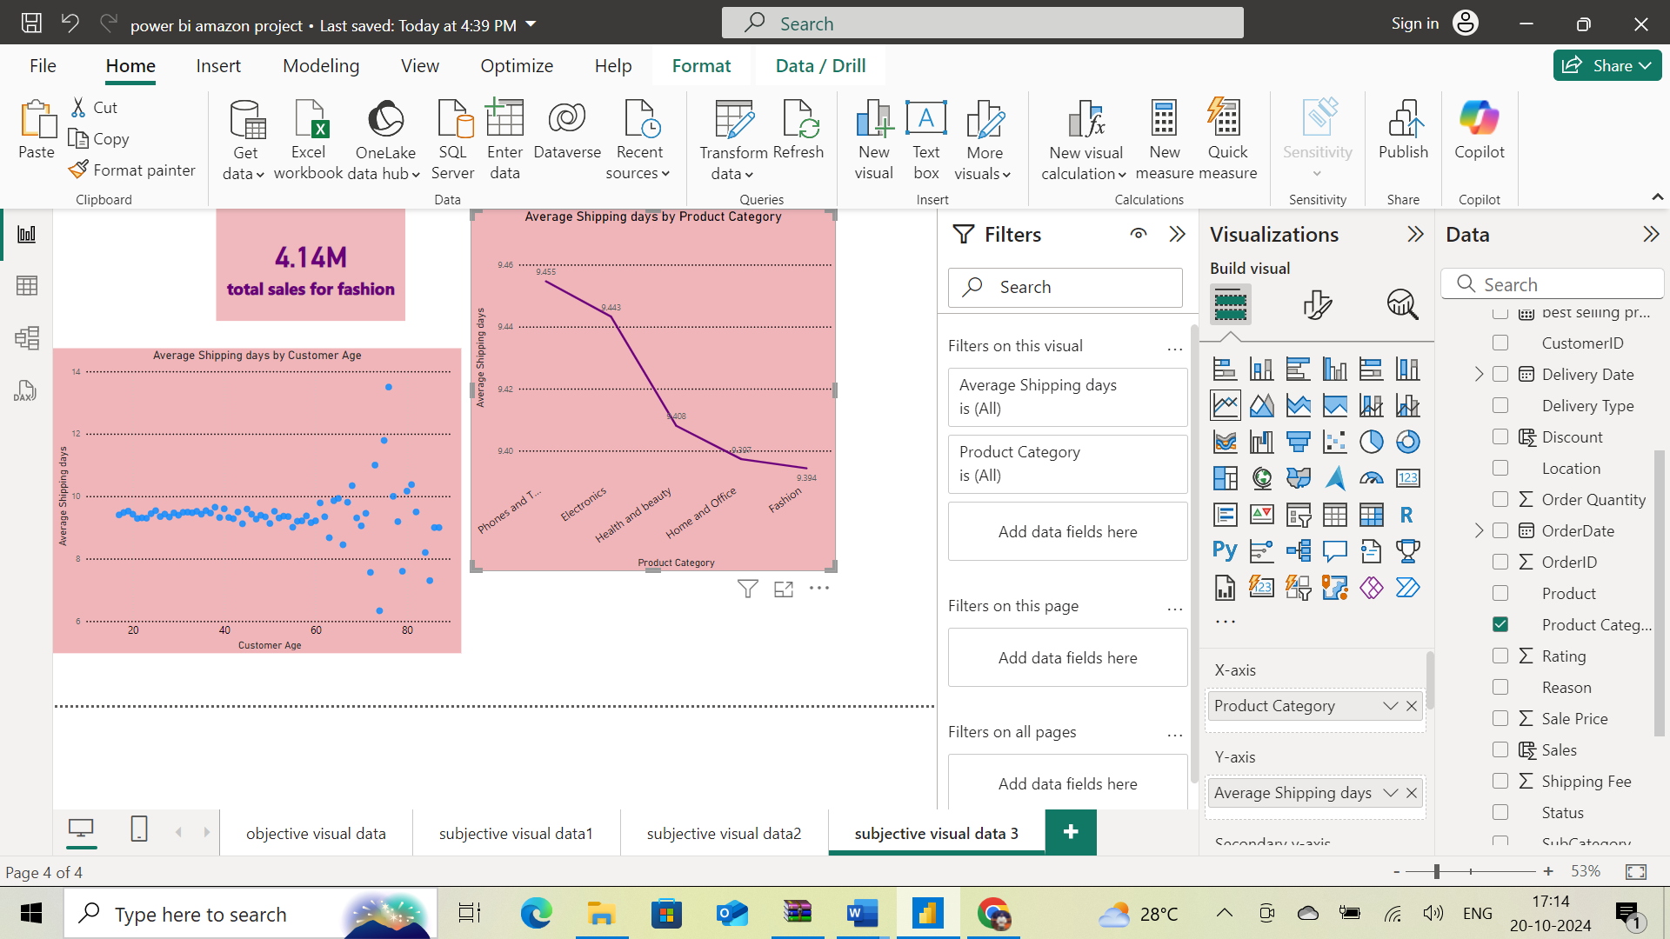

1. Explore if there is any relationship between the Delivery type and waiting time between ordering and receiving an item.

**Ans:**

**Insights:**

* asking to find between the Delivery type and waiting time between ordering and receiving an item.

**Approach:**

* I used a line chart to solve this, using columnsDelivery type on x-axis and shipping days on y-axis.
* Used format visual for chart style.

**Recommendation:**

* As we can see in the below Line chart, there are mainly 3 different delivery types. Each delivery type has a different delivery time. Express delivery has an average of 3.49 days. Standard delivery type has an average of 10 days to deliver the product. Products from abroad will take more days to deliver.

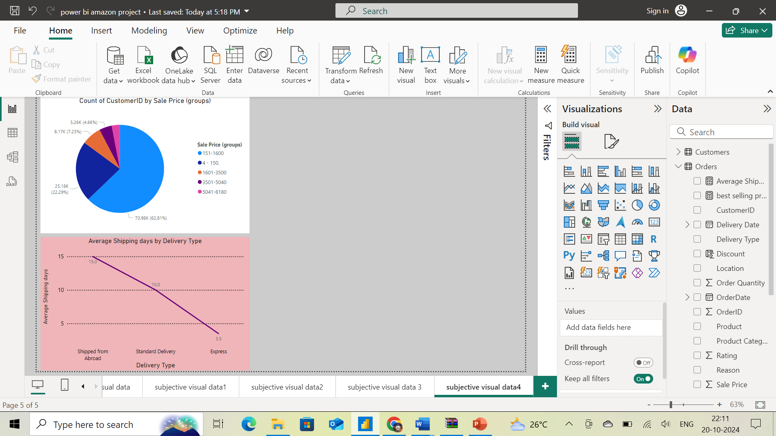

1. Is there any relationship between shipping charges and product type?

**Ans:**

**Insights:** task is to find a relationship using shipping fee and product category

**Approach:**

* To solve this, I used area chart with columns product category in x-axis and average shipping fee in y-axis.
* Used format visual for chart style.

**Recommendation:**

* By using Area chart with Product Category in X-axis and Average of Shipping fee in Y-axis, we can see the relationship between Shipping fee and product category. As we can see in the chart, Health and Beauty have high average shipping fee.

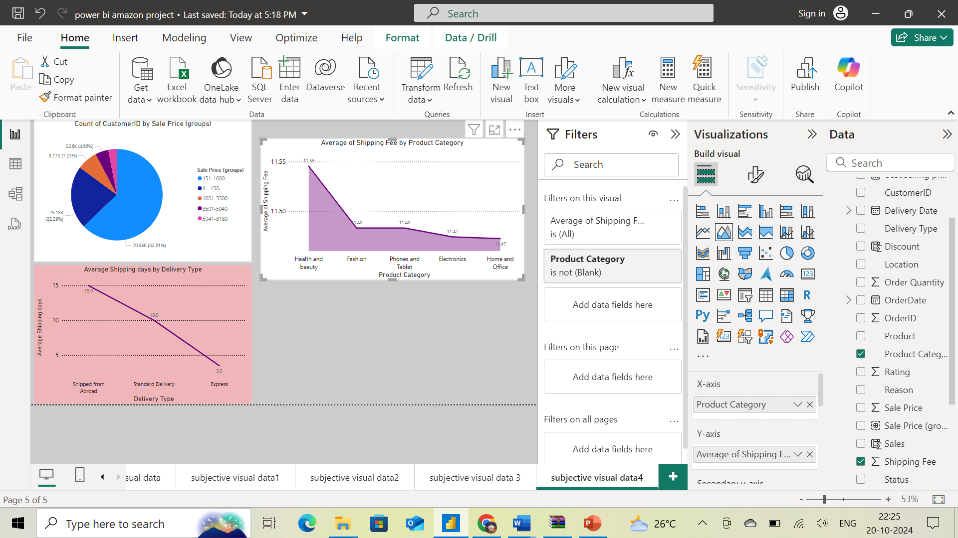

1. Come up with strategies to decrease the low rating orders after analyzing different factors like waiting time, shipping type, unit price, etc.

**Ans:**

**Insights:**

* Asking To come up with different strategies to decrease the low rating orders, I have analysed the waiting time, unit price for each rating.

**Approach:**

* Here I used Line chart to display the waiting time and unit price for each rating.
* In the below line chart, we can see for 5 rating the average delivery time and average unit price is low compared to other ratings.
* Used format visual for chart style.

**Recommendation:**

Strategies to decrease low rating orders:

* We can decrease the low rating orders by decreasing the delivery time. This can be done by offering them different delivery options like Express delivery, Standard delivery etc.
* By lowering the unit price, low rating orders can also be reduced.

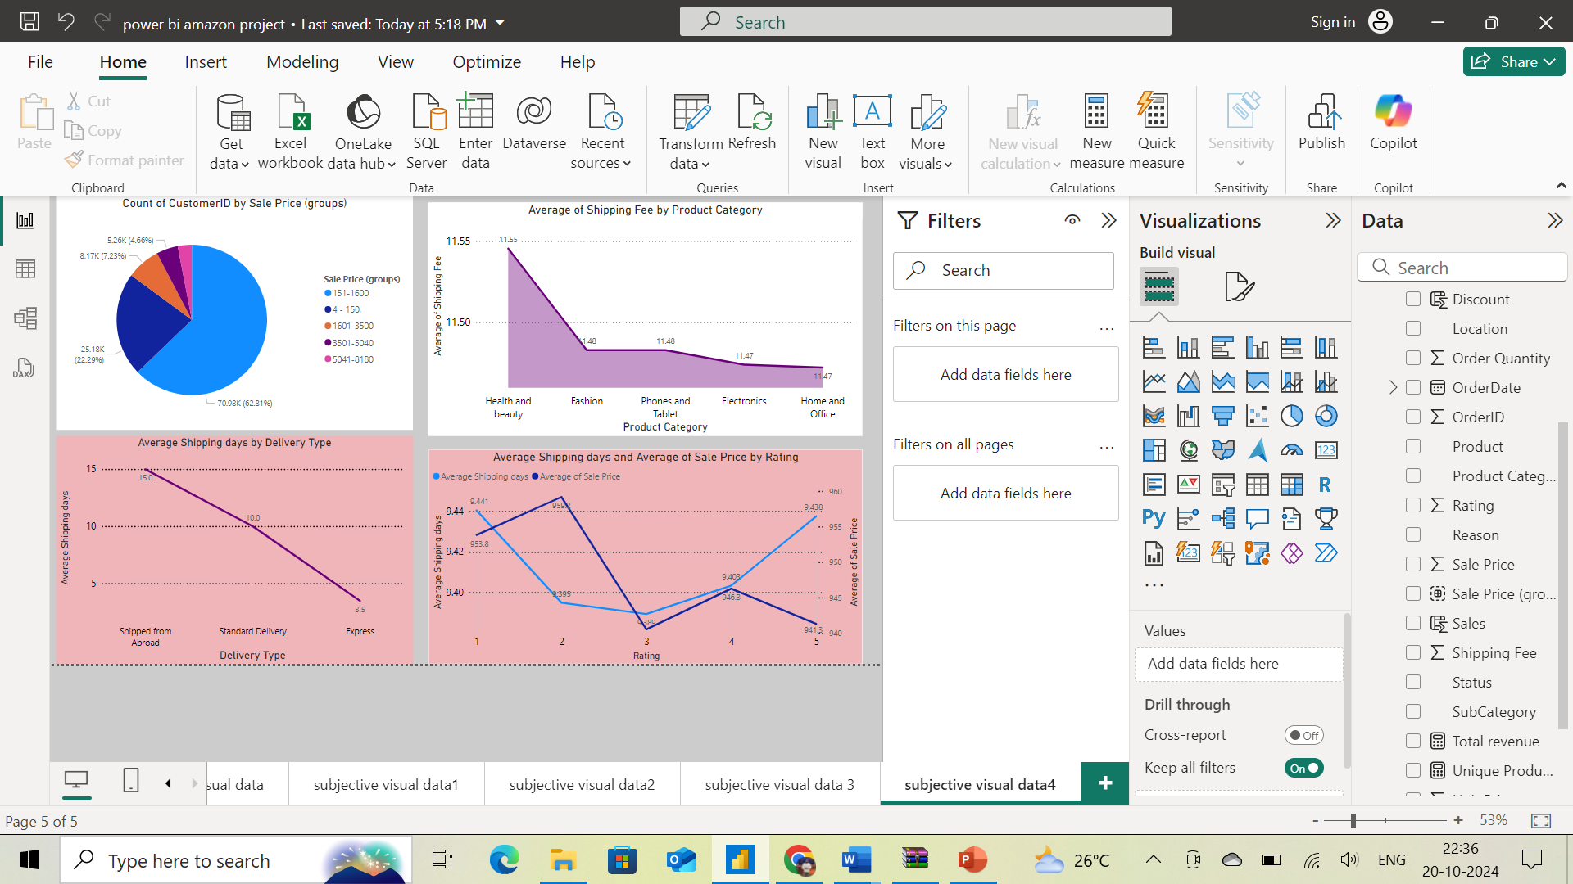

1. Using the time intelligence DAX function, create a table to compare each month’s sales with the previous year’s same month’s total sales. So there will be four columns in the output year, month, total sales, previous_years_sales.

**Ans:**

**Insights:** Above task is asking to create table using DAX function with using time intelligence in 4 columns like year, month, total sales, previous_years_sales.

**Approach:**

* Iused a table card from visualization panel. Created a table with columns given in data like from order date with year,month,total revenue
* For previous_years_sales. Created a new column using below DAX formula
* Using basic filter for filtering where required.

Dax formula for Last Year Total Revenue:  **Total revenue last year = CALCULATE([Total revenue],SAMEPERIODLASTYEAR(Orders[OrderDate]),ALLEXCEPT(Orders,Orders[OrderDate]))**

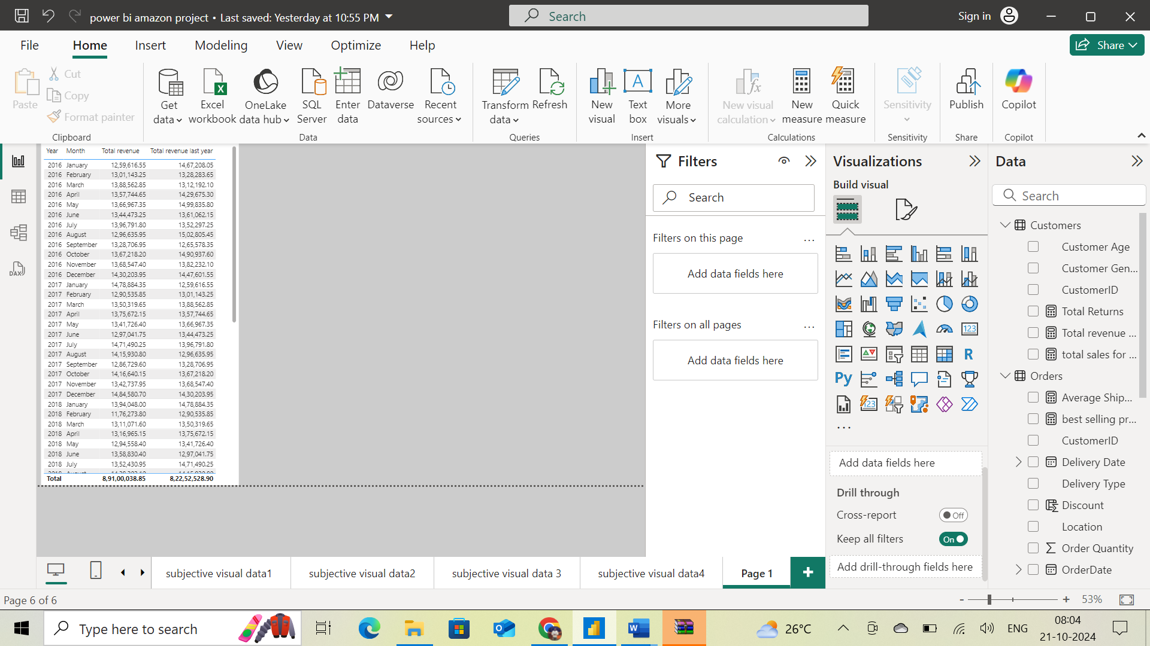

**Recommendation:** the above tables show the required output for this task

1. What do you understand by PowerBI gateway? What are its use cases?

**Ans:**

Power BI Gateway is a bridge that enables secure data transfer between on-premises data sources and the Power BI service in the cloud. It allows users to access and refresh on-premises data in real-time or at scheduled intervals for Power BI reports, dashboards, and datasets.

Key Components of Power BI Gateway:

1. **On-premises Data Gateway (Standard Mode):**
   * Designed for multiple users to connect to on-premises data sources like SQL Server, Oracle, SharePoint, etc.
   * It supports both live queries and scheduled refreshes of the data in the Power BI cloud service.
2. **On-premises Data Gateway (Personal Mode):**
   * Designed for a single user, typically used for personal datasets.
   * It only supports scheduled refreshes, not live connections.

Use Cases:

1. **Scheduled Data Refresh:**
   * Power BI Gateway allows users to set up scheduled refreshes for their datasets. This ensures that the reports and dashboards are based on the most recent data without needing manual updates.
2. **Live Data Connectivity:**
   * It supports real-time data access through live connections to on-premises databases like SQL Server or Oracle, so Power BI dashboards can display real-time updates.
3. **Hybrid Environments:**
   * In organizations using a hybrid cloud setup (mix of on-premises and cloud-based solutions), the gateway enables seamless integration of on-premises data sources with Power BI in the cloud.
4. **Secure Data Transfer:**The gateway ensures secure data transfer between on-premises sources and the cloud using encryption protocols. No data is stored in the cloud during the transfer, enhancing security.
5. **Multi-User Environments:**
   * The standard mode of Power BI Gateway allows multiple users to connect to and query data sources, which is useful in enterprise settings where teams share dashboards and reports.
6. **Other Integrations:**
   * Beyond Power BI, the gateway also supports other Microsoft services like Power Automate, Power Apps, and Azure Logic Apps, allowing broader use in automating workflows and applications.

In summary, Power BI Gateway is essential for enabling hybrid data connectivity and ensuring secure, scalable data transfers between on-premises sources and cloud-based services in Power BI.

1. How would you approach this problem, if the objective and subjective questions weren't given?

**Ans:**

• **Understand the Business Context**: Gather detailed information about the business objectives, challenges, and goals to ensure a clear understanding of the problem at hand.

• **Decompose the Problem**: Break down the overarching problem into smaller, specific components, focusing on key areas like sales performance, customer behavior, and product trends.

• **Generate Actionable KPIs**: Develop relevant KPIs based on the problem breakdown, such as sales growth, customer retention rates, and top-selling products, ensuring they align with business goals.

• **Data Collection and Analysis**: Collect accurate data, analyze it using tools like Power BI and SQL, and refine the KPIs as needed to stay aligned with the objectives.

• **Report Findings and Recommendations**: Compile insights into a report, providing clear, actionable recommendations that address the initial business problem and drive desired outcomes.